**WP3 – Design and structure of the IMI Neurodegeneration Knowledge Base (INKB)**

Contents

Introduction 2

Landing page 2

Registration page 3

Log in page 4

Users and permissions 5

Dashboard prototype 6

Modules in the dashboard 7

1. PROJECTS 7

2. ACTIVITY 8

3. CONTACTS 9

4. DOCUMENTS 10

5. PUBLICATIONS 10

6. CALENDAR 11

7. METRICS 12

8. SCHEDULE 13

9. DELIVERABLES 13

Forum 15

# Introduction

* The INKB will be a web platform that acts as portal for the IMI Neurodegeneration (ND) programme (it is not the main public project website).
* Its primary users are going to be IMI staff, IMI ND project leadership teams, and members of the IMI Neurodegeneration SGG.
* The idea for the INKB is to provide an overview or summary of the IMI Neurodegeneration programme, in the format of a dashboard (i.e. a graphical summary of various pieces of important information) to give an overview of the IMI ND portfolio.
* User-friendliness is key - the INKB must be a usable and useful tool, with appropriate interfaces, search capabilities, etc.
* The INKB would be a public tool, therefore the information registered from projects should be public.

# Landing page

The landing or welcome page of the INKB will be the first page people encounter prior to their registration as users. It should include:

* NEURONET logo
* Full project name
* Invitation to *Log in / Register*
* Link to main NEURONET website
* Link to Twitter profile/other social media (tbc)
* Salutation text

Example:

*“Welcome to NEURONET IMI NEURODEGENERATION KNOWLEDGE BASE (INKB)*

*The main aim of NEURONET INKB is to serve as an overview of projects and activities within the IMI ND programme. The NEURONET INKB provides relevant information about IMI ND projects (such as publications, deliverables, etc). Furthermore, it includes useful reference documents (such as templates, guidelines, etc.) and a section with contact details of experts in key project areas (such as sustainability, ethics, data sharing, regulatory/HTA, communication and management).”*

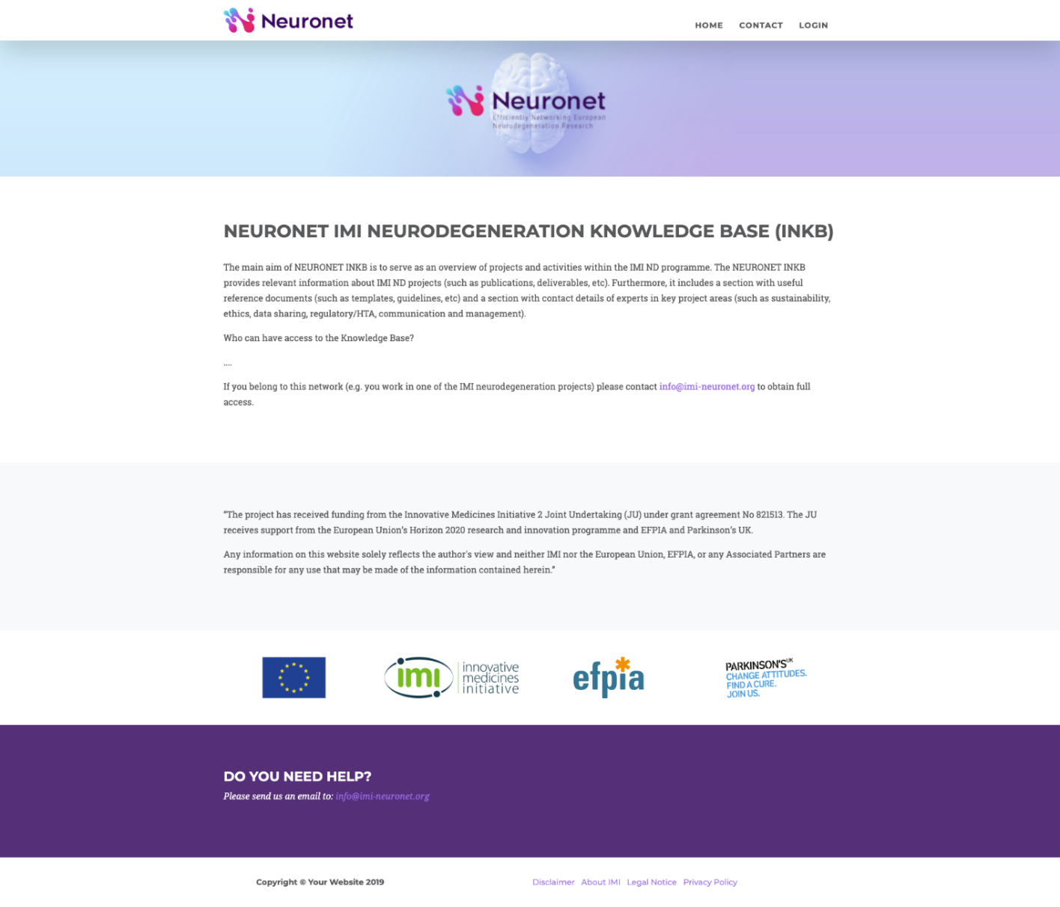

# Registration page

The registration page would require new users to provide some personal information (considering GDPR compliance). This could include:

* Full name
* Institutional email address
* IMI ND project/s he/she participates in. A single person could be involved in different projects, to be discussed how to register these cases.
* Job position: CEO, Director, PhD student, Research assistant, Post-doc, Principal investigator, Project Manager, etc.
* Role in the project: Project Lead, Coordinator, Principal Investigator, etc.
* Education might also be registered: BSc, MSc, PhD, MD etc.
* Area of expertise/scientific background
* Institution.
* Country.
* Profile photo (optional).

**For discussion**: Other fields (sex, age…).

# Log in page

# 

# Users and permissions

Access to the INKB would require prior registration. Therefore, all users will be identified users.

After submission of personal information in the registration page the site admin (process to be defined) will review and approve the petition and a confirmation email will be sent to the new user.

Types of users:

* NEURONET Consortium members
* IMI ND Projects leadership teams
* IMI staff
* IMI Neurodegeneration SGG members

**For discussion:**

The dashboard could potentially show different modules depending on the type of users, but technically this would add complexity, plus it would go against the aim of the dashboard being a public portal.

Discuss registrations from people who are not involved in IMI ND Projects or working in science/research. Examples of similar tools dealing with this issue being reviewed by the NEURONET Consortium:

* DPUK only accept bona fide researchers for the data portal - to find out more about how they addressed this issue.
* Research Gate: <https://explore.researchgate.net/display/support/Signing+up+for+ResearchGate>
* Aetionomy KB: <https://data.aetionomy.scai.fraunhofer.de/general-public>

Permission levels being considered:

1. **Admin**:

Can list, create, read, update, download and delete all contents in the system, including users and user passwords.

Admin access will be granted to some partners of the NEURONET Consortium.

1. **Editor**:

Can list, create, read, update, download and delete all contents.

Editor access could be granted to IMI ND Projects leadership teams.

Preferable, each project should designate 1-2 people to feed information about their own project into the INKB (e.g. from the Project Management Team or the Communications team). 🡪 to be discussed at the SCB meeting.

Detailed ‘input forms’ will be used to ensure information is provided in a similar format for all projects,

1. **Subscriber**:

Can list, read and download contents.

Subscriber access should be granted to SGG members and IMI staff.

# Dashboard prototype

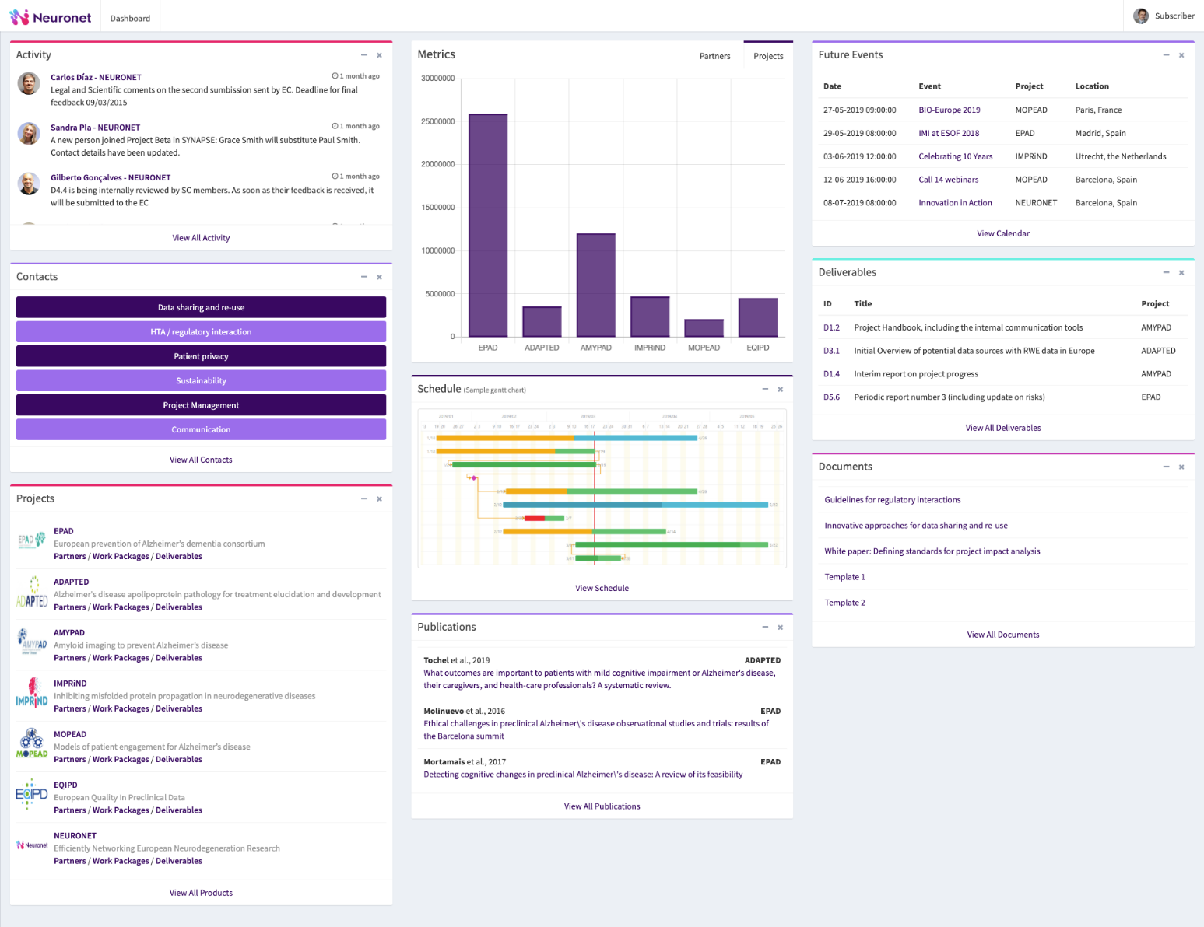Top left corner: NEURONET logo

Top right corner: miniature profile picture of user and section “My profile” with options to edit user details, change password, etc.

The website is designed in three columns to optimize visualisation (a different number of columns could be used if needed but implications must be considered: correct visualisation of graphs, font size etc).

# Modules in the dashboard

## PROJECTS

This module would gather information about the IMI ND projects that are part of NEURONET. Projects could be grouped according to their status: active or completed.

List would include: Project logo, project acronym and full project title followed by 4 links below:

*Partners / Work Packages / Deliverables / Website*

Each of these links would open a new page:

* Partners: List to include institution names and countries.
* WPs: List to include WP id + WP titles (IMI format).
* Deliverables: List to include deliverable id + WP + full deliverable title. Each project will decide the deliverables they wish to list in the INKB. To be discussed at the SCB meeting.

The deliverables listed will be linked to any reports, tools or databases that might be accessible from the project website. Added link to the ID in the Deliverable module, if the Deliverables link from a project is clicked in the project module, the system will redirect users to a list of deliverables of that particular project, each item in the list will have a link to that deliverable.

* Assets & Tools. List of project tools, databases, cohorts, etc. developed by the projects. Provide info about who is sustaining these databases, acting as gate keepers, overview of the classes of data available and in what format etc. To do this we will need to add a new module called Assets & Tools, to generate it I will need a list of fields that needs to be added to the new module, for instance tool name (or name), link to the resource, etc. Alternatively, I will need to have examples of the elements that needs to be included in this section to define the fields.
* Website: Link to public project website.

Logo **AMYPAD**

Amyloid imaging to prevent Alzheimer’s disease

*Partners / Work packages / Deliverables / Assets & Tools / Website*

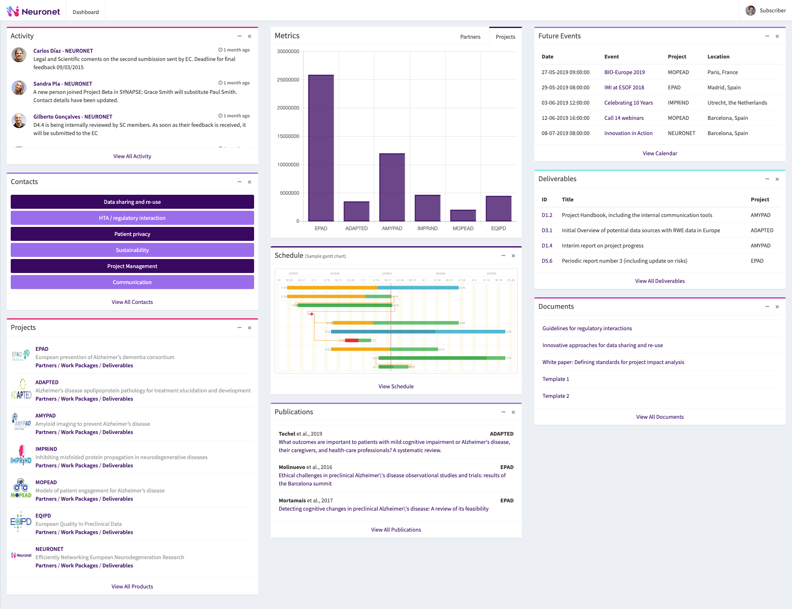

**For discussion:**

* Including only the most important deliverables per project (input from the IMI ND Project leads would be required). 🡪 each project will decide
* Since a few of the IMI ND projects have recently finished or are quickly approaching completion having developed project tools and databases that are listed in the IMI catalogue of project tools (<https://www.imi.europa.eu/projects-results/catalogue-project-tools>) discuss whether to add another tab for *Project tools.* 🡪 accepted
* Suggestion to add a tab related to project resources, such as documentation generated for interactions with regulatory bodies or presentations that describe aspects of the projects. However, at least some of these documents could also be included in the module Documents, where several tools, templates and guidelines will be provided for consultation. 🡪 for the time being we will not add this as a new tab.
* Open question about how to deal with an increasing number of projects in this module. As the list of projects expands, discuss what projects are shown on top of the list in the dashboard, and how the newest projects are displayed. 🡪 projects will be listed alphabetically, it will be possible to see the complete list by clicking “View all projects”.

## ACTIVITY

This module would contain short twitter-style messages (but it will not be linked to the project’s Twitter). The idea is that Coordinators/Project Leads and/or Project managers can post updates or make specific comments/requests in this section with the aim of reaching out the IMI ND Projects.

All messages would include: user photo, author name, project name,date of publication and text message. In case one person is involved in several projects there should be a way to select the project related to the message being published (e.g. from a drop-down list).

To explore feasibility of adding a “LIKE” button to promote communication/interactions.

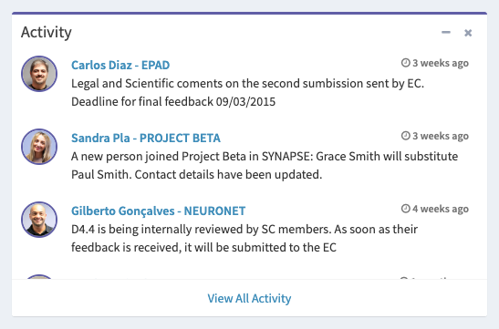

By clicking *View all activity* or the title (header) of the module a new window would open showing the complete list of messages. The page would include a search bar in the top right corner to allow users to search by project name, specific words, author name…

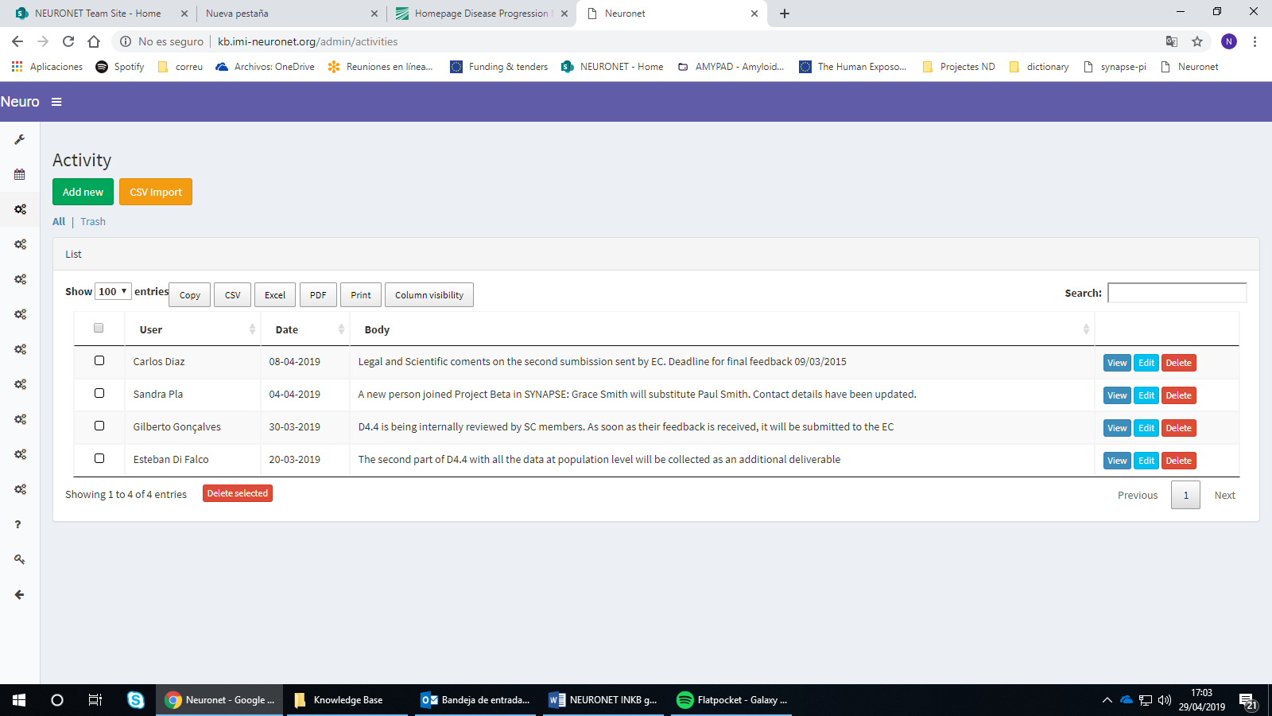

## CONTACTS

This module could show the 6 categories of contacts (but this number could grow in the future):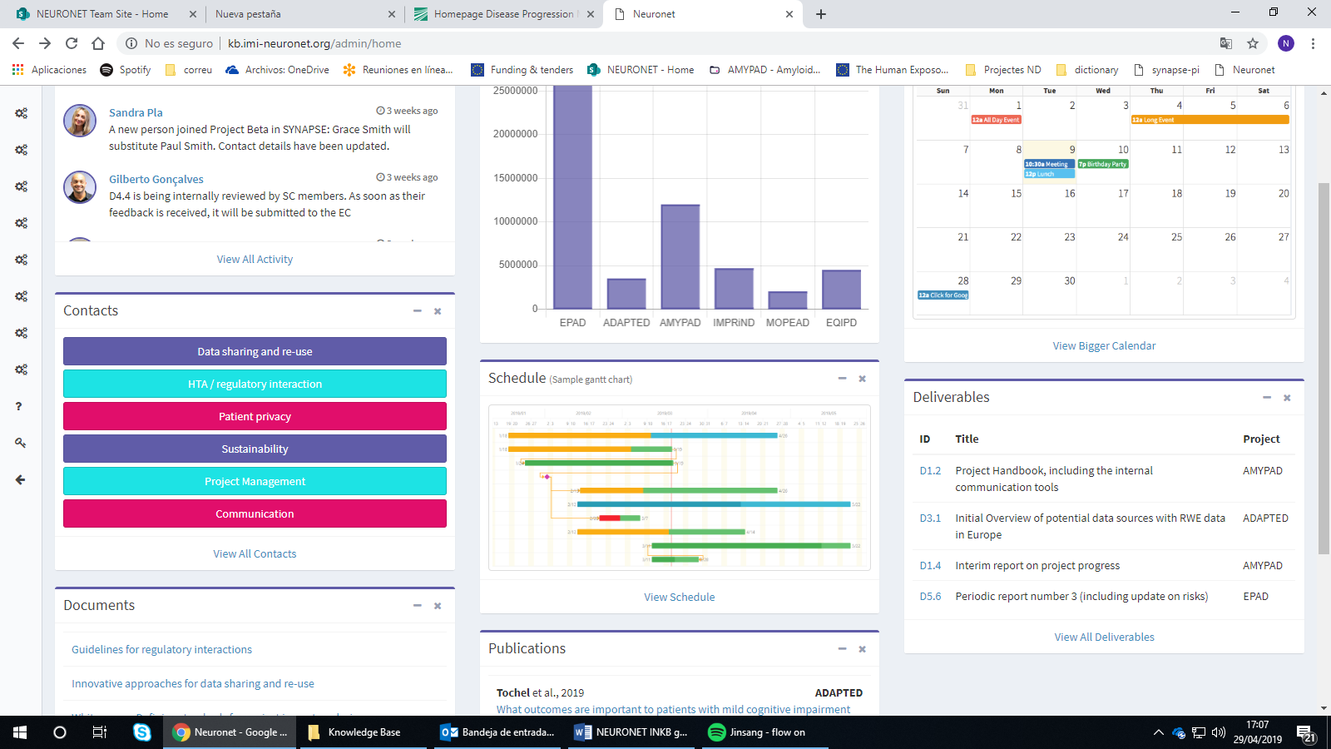

By clicking on one of these categories, a new window will open displaying a list with the contact details of experts belonging to that category (GDPR compliance to be considered). List would include:

* Full name
* Email
* Position (i.e. Head of Department X, Project Manager, etc)
* Institution
* Names of project/s he/she is involved in
* Expertise – briefly describe their areas of expertise. Field Added to the KB

*View all contacts* would open a new page with all contacts, but unsorted. Page would include a search bar to allows users to search by project name, contact name, etc.

Important to consider GDPR. Data must be regularly updated and checked by law – every two years?

## DOCUMENTS

This module would contain a list of general relevant documents for all IMI ND projects, with a link for download. List would include: Document title + download link or title of document hyperlinked. (Must allow downloading pdf/word/xls).

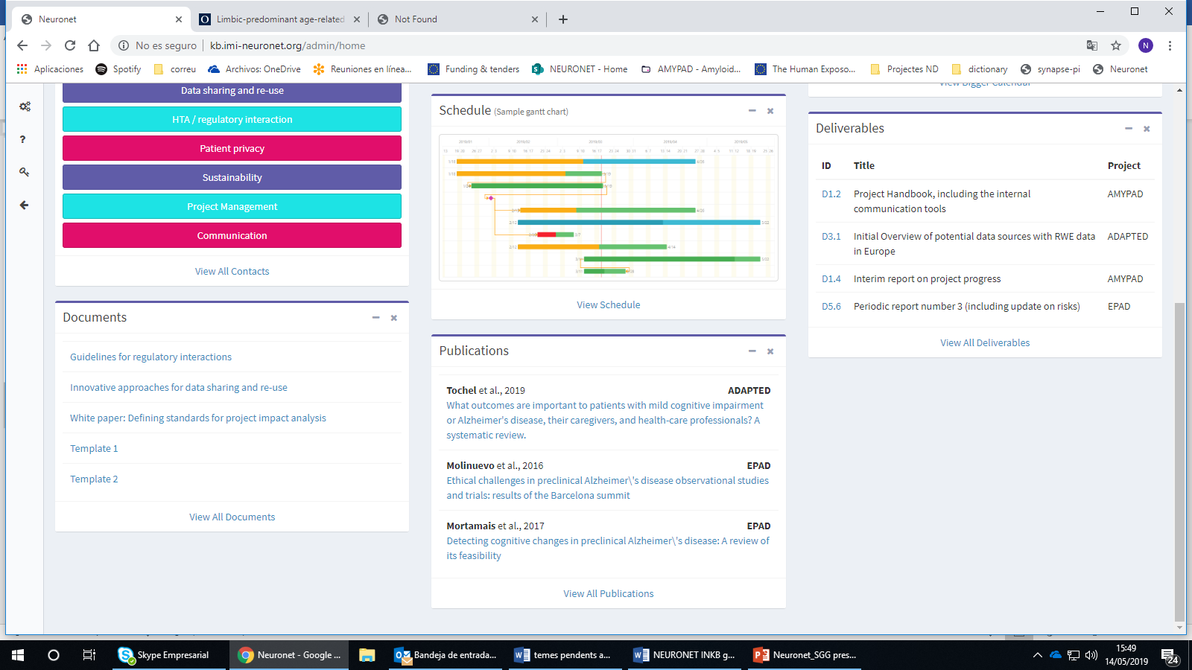

By clicking *View all documents* or the title (header) of the module a new window would open, displaying a list showing all documents available. This page would include a search bar to allow users to search documents containing specific words (but it would search only in the doc title, not in its body).

**For discussion:**

* Not including project names, as the intention is not to upload specific project documentation but general templates, tools, guidelines etc that are of interest for all projects.
* Discussing whether the most recently uploaded documents should be displayed on top of the list for a limited period (e.g. two weeks, one month) highlighted in some way to show they’re NEW documents in the INKB. Older documents could be shown down below, in alphabetical order or by number of downloads.

## PUBLICATIONS

This module would show relevant publications based on work generated within the IMI ND projects (containing the required IMI JU acknowledgement).

For each publication, include: first author, publication year, project name and full title of publication hyperlinked to its DOI (The DOI is used to identify objects uniquely and it does not change over time, therefore it is better than a website link).

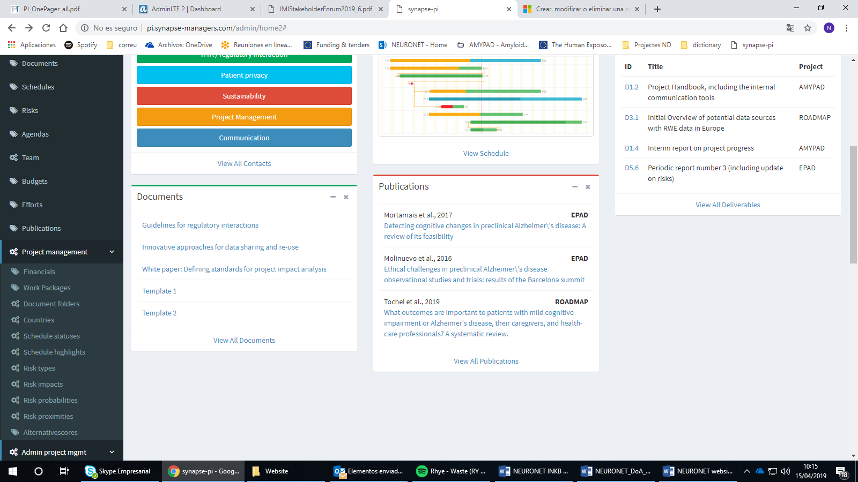

By clicking *View all publications* or the title (header) of the module a new window would open displaying the complete list of publications. Page would include a search bar to allow users to search by project name, author name etc.

**For discussion:**

* Suggestion to include an additional category under Publications module that could be used for linking to press releases and lay media coverage. E.g. have one category entitled ‘journal articles’ and another for ‘media coverage’.
* Discussion about including conference abstracts too. Sometimes these are published by journals as conference proceedings (e.g. AAIC abstracts are published in Alzheimer’s and Dementia), so are searchable through Web of Science.

## CALENDAR

This module would display information about events, conferences and meetings. It would include: Date, event title, project and location.

By clicking *View all events* or the title (header) of the module a new window will open displaying the complete list of events. Conferences could be hyperlinked to the respective websites. Page will Include a search bar to allow users to search by project name, event location, etc.

Format could be:

|  |  |  |  |
| --- | --- | --- | --- |
| DATE | EVENT | PROJECT | LOCATION |
| 12 June 2019 | IMI Stakeholder Forum | - | Brussels, Belgium |
| 2 July 2019 | NEURONET Scientific Coordination Board Meeting | NEURONET | Madrid, Spain |

**For discussion:**

* Discussion about what kind of events will be included here, i.e. only major events and conferences and/or also the projects’ internal meetings.
* Suggestion to use different colours for the events of the different projects to differentiate them easily.

## METRICS

**Contents of this module are open for discussion.**

The initial proposal is to display here *some* of the Key Performance Indicator (KPI) data collected by WP1. The broad dimensions or areas currently being considered are shown in this figure:

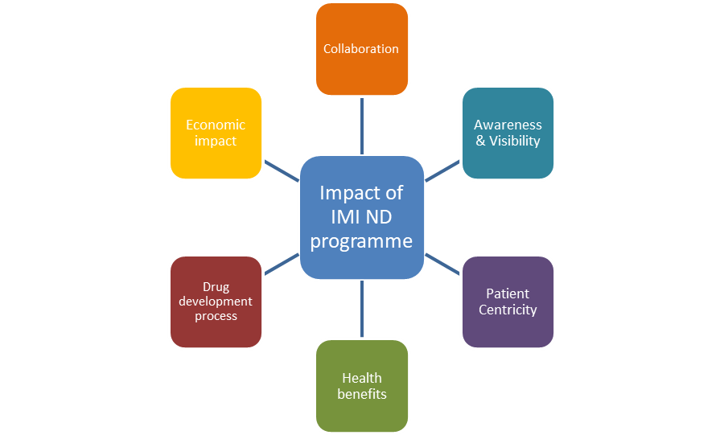

Some NEURONET partners have expressed they would like the SGG to provide feedback and ideas about the information they would find most useful to be shown in this module.

Data could be presented using different kinds of graphs:

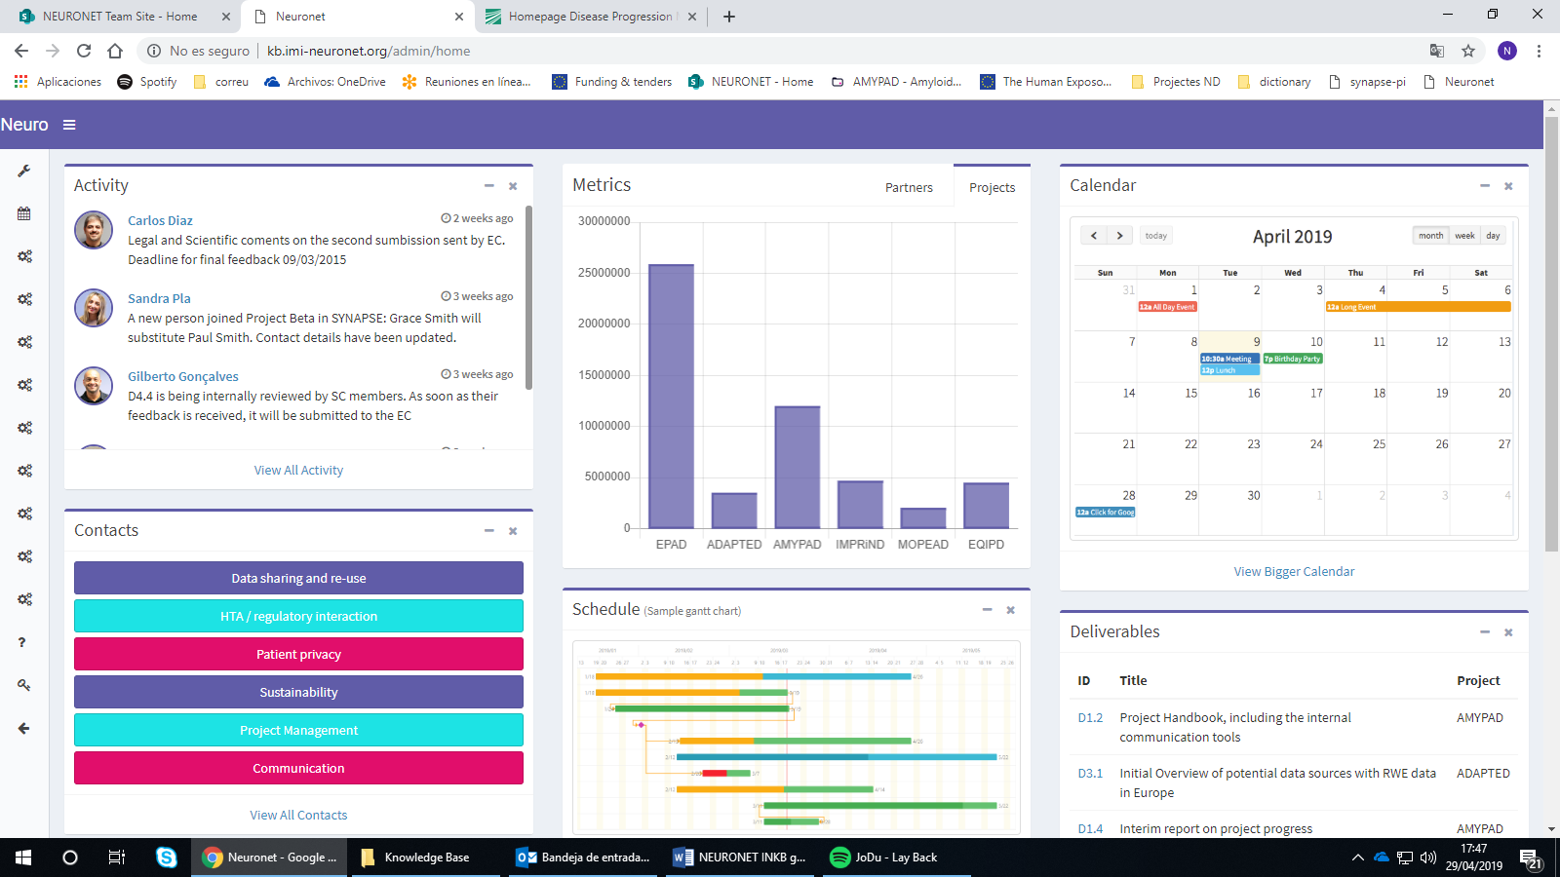 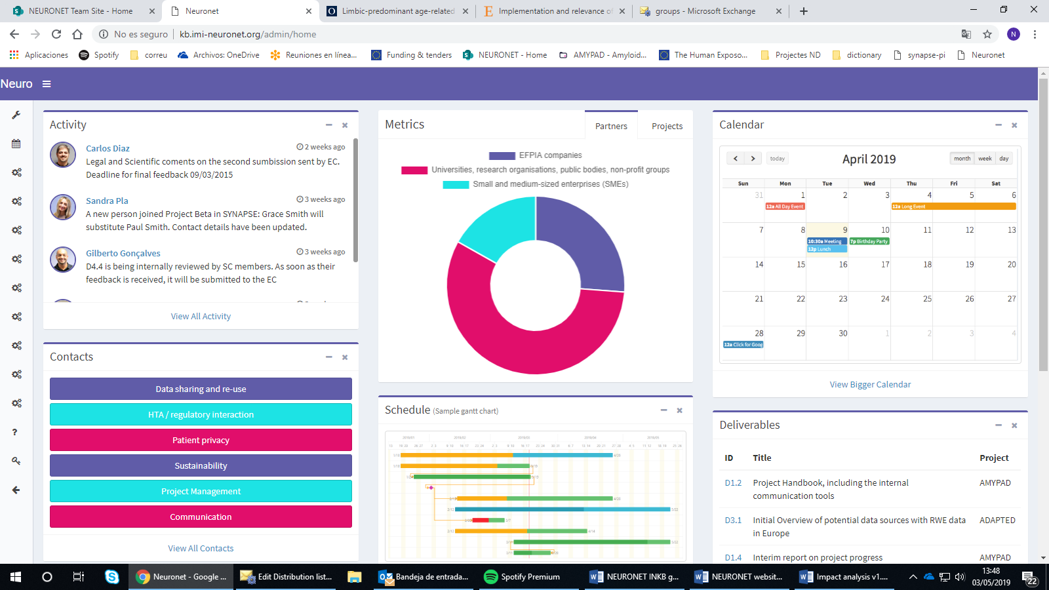

## SCHEDULE

The initial idea would be to include here a meta-Gantt chart for all projects.

Example:

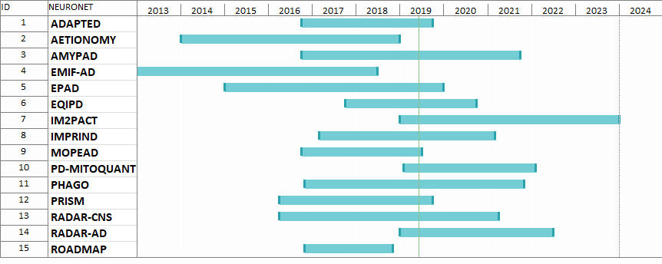

**For discussion:**

* How to show in one single picture all the project timelines in an understandable manner
* Doubts about the relevance/value of this module.

## DELIVERABLES

This module would display projects’ deliverables, including: deliverable ID, title, WP name (e.g. Dissemination & Communication) and project title.

Each project will decide the deliverables they wish to list in the INKB. To be discussed at the SCB meeting.

The deliverables listed here will be linked to any reports, tools or databases that might be accessible from the project website. Added the field link to the Deliverable admin section, admin and editors will be able to add an external link to each deliverable and when a user clicks on the ID of the dashboard it will be redirected to that link.



By clicking *View All deliverables* or the title (header) of the module a new window would open displaying all projects’ deliverables in a list/table. Page will include search bar that allows users to search by project name, etc.

**For discussion:**

* It has also been discussed that it would be good to include an option to subscribe to deliverables that are not yet available, to be alerted via email notification when a pdf/word is uploaded. This could be discussed in the future, in the next phase of development, considering IT requirements.

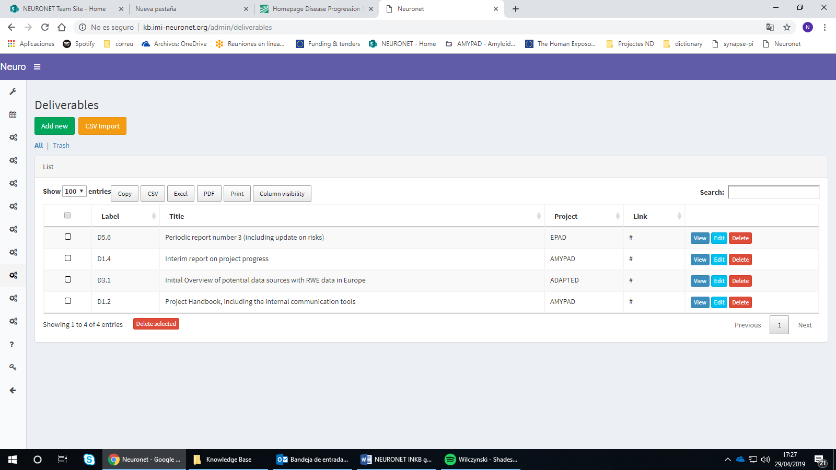

# Forum

The INKB might include a forum space to promote dialog and discussions across projects and reinforce the sense of “IMI neurodegeneration community”.

**For discussion:**

The Forum could either be displayed in the dashboard as another of the INKB modules, or it could appear as a link in the top ribbon that would open in a separate page.

The forum could be also accessed through the public project website (as an intranet).

Options being explored:

* <https://laracasts.com/discuss>
* <https://www.discourse.org/>